Purpose of This Document
This document serves as the foundational reference for building, populating, and demonstrating ContinuumAI using the SilkRoute company.
It brings together:
- the business model and product lines
- the core data entities and schemas
- intentional SWOT-style performance patterns
- grouped analytical use cases from descriptive to prescriptive
Together, these sections ensure that:
- synthetic data generation reflects realistic business behavior
- AI-driven insights are explainable and strategy-aware
- ContinuumAI demonstrations clearly show progression from insight to action
This document is intended to be used by product, data, and AI teams as the single source of truth for the ContinuumAI MVP.

SilkRoute – Company Overview (ContinuumAI MVP)

1. Company Profile
Company Name: SilkRoute
Headquarters: Pakistan
Channels:
- Physical retail: SilkRoute (brick-and-mortar stores)
- Online retail: SilkRoute Online (Pakistan-only ecommerce)
SilkRoute is an omnichannel retail company combining fashion and consumer electronics, selling branded products only. The company operates physical stores across major Pakistani cities and an online channel serving customers nationwide.
The business is designed to demonstrate how data-driven decision-making can improve retail performance using ContinuumAI, an AI-powered analytics and intelligence platform.

2. Business Model
SilkRoute generates revenue through direct-to-consumer retail sales across two channels:
- In-store sales: Assisted selling through trained sales staff
- Online sales: Direct ecommerce transactions within Pakistan
Key characteristics:
- Single-country market (Pakistan)
- Single currency
- No private-label products
- Focus on basket growth, attach sales, and repeat customers

3. Product Lines
SilkRoute’s assortment mirrors a modern omnichannel retailer:

Fashion
- Apparel: cotton t-shirts, casual shirts, denim jeans, hoodies, formal trousers
- Footwear: running shoes, casual sneakers, sandals, formal leather shoes
- Accessories: belts, wallets, scarves, caps

Electronics
- Smartphones: mid-range Android phones, flagship Android devices
- Laptops: ultrabooks, gaming laptops, business laptops
- Audio devices: wireless earbuds, over-ear headphones, Bluetooth speakers
- Consumer accessories: power banks, phone stands, USB hubs

Attach & Add-ons
- Chargers: fast chargers, wireless chargers, laptop power adapters
- Cases & protection: phone cases, laptop sleeves, screen protectors
- Extended services: warranty extensions, accidental damage protection

4. Core Business Entities (ContinuumAI MVP)
The following entities form the foundation of SilkRoute’s analytics model, along with the key data points stored for each entity.
Entity | Purpose | Key Data Points (comma-separated)
Transaction | Order-level sales context | transaction_id (unique order id), transaction_ts (date/time), channel_type (store/online), store_id (nullable), customer_id, salesperson_id (nullable), payment_method, total_amount
Transaction Lines | Item-level basket details | line_id, transaction_id, sku_id, quantity, unit_price, discount, line_total
Promotion | Product-level promotion context | promo_id, product_id, promo_type, start_date, end_date, discount_type
Product | Parent product / style | product_id, product_name, brand, category, subcategory, status
Product Variant (SKU) | Sellable unit | sku_id, product_id, size (if applicable), color (if applicable), base_price, active_flag
Variant Attributes | Flexible SKU attributes | sku_id, attribute_name, attribute_value, attribute_type
Category Attribute Definitions | Allowed attributes per category | category, attribute_name, attribute_type, required_flag
Customer | Buyer identity & segmentation | customer_id, segment, city, region, first_purchase_date
Store | Physical retail context | store_id, store_name, city, region, store_type
Channel | Sales channel context | channel_type, channel_name
Salesperson | In-store staff | salesperson_id, name, role, store_id
Inventory Snapshot | Stock state over time | snapshot_date, store_id, sku_id, stock_on_hand, stock_on_order
Returns | Post-sale behavior | return_id, transaction_id, sku_id, return_reason, refund_amount
Inventory, sales, and returns operate at the SKU level. Promotions are defined at the product level and inferred at transaction time based on product, date, and channel.
These entities are intentionally minimal yet sufficient to demonstrate descriptive, diagnostic, predictive, and prescriptive analytics in ContinuumAI.
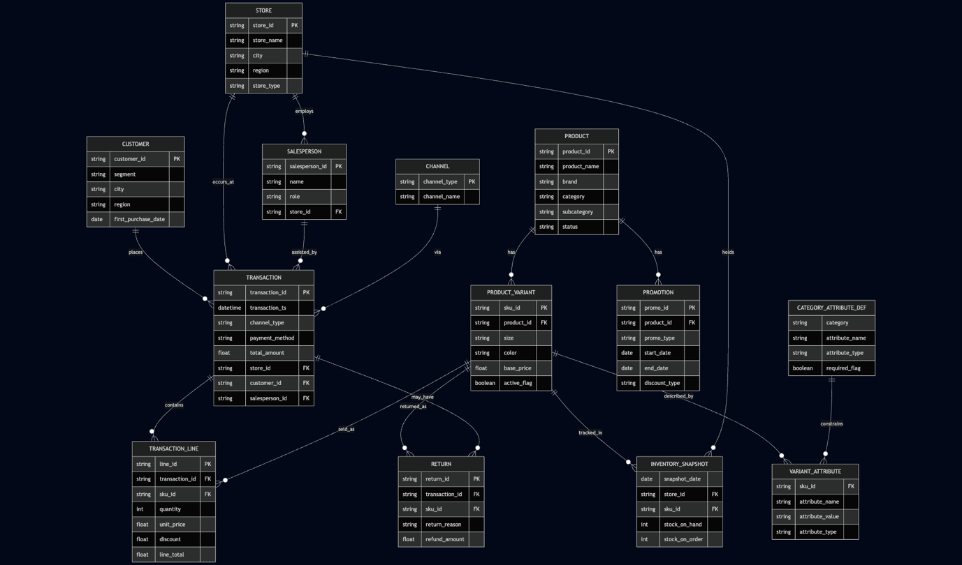

5. Operating Scale (Synthetic Data Targets)
To support realistic patterns, we need:
- Stores: 5–6 physical stores across 2–3 cities
- Products: ~150 SKUs across fashion, electronics, accessories
- Customers: 2,000–3,000
- Transactions: ~15,000 over 12 months
- Transaction lines: ~30,000 (average basket > 1)
- Salespeople: 20–30
- Returns: 8–12% of transactions

6. SWOT-Oriented Pattern Design (for Data Generation)
This section defines intentional strengths and weaknesses to be reflected in synthetic data.

Strengths
- Strong online sales growth compared to some physical stores
- A small set of high-performing hero products
- Top salespeople with strong attach rates and low discounting
- Loyal repeat customers contributing disproportionate revenue

Weaknesses
- Over-reliance on a few best-selling SKUs
- Margin erosion due to discount-heavy selling
- High return rates for specific products or categories
- Underperforming stores with low conversion

Opportunities
- Improve basket size via accessories and add-ons
- Upskill low-performing sales staff
- Reduce returns through better product and category decisions
- Shift growth toward higher-margin products

Threats
- Stock-outs on high-demand products
- Price-sensitive customers eroding margins
- Poor-performing stores dragging overall performance
- Repeat return behavior from specific customers or products

7. Good vs Bad Patterns to Seed
The dataset should intentionally include:
- Good vs bad customers (high CLV vs one-time or high-return)
- Good vs bad products (high-margin vs high-return)
- Good vs bad stores (high conversion vs low conversion)
- Efficient vs inefficient salespeople
- Products with repeated return issues
These contrasts allow ContinuumAI to surface insights, explanations, and recommendations.

8. Company Targets (Strategy Layer Inputs)
SilkRoute operates with the following high-level targets:
- Grow revenue without increasing discount dependency
- Improve gross margin and attach rates
- Increase repeat purchases and basket size
- Reduce return rates for top-selling products
- Lift underperforming stores and salespeople toward network average
- Reduce stock-outs on high-demand items
These targets are consumed by ContinuumAI’s strategy layer to guide AI-driven insights and recommendations.

9. ContinuumAI Use Cases Overview
This section outlines how ContinuumAI delivers value across increasing levels of analytical maturity. The use cases are grouped to clearly demonstrate progression from basic reporting to AI-guided decision-making. This structure helps stakeholders understand how insights evolve into actions and why ContinuumAI goes beyond traditional BI.
The following tables group ContinuumAI’s use cases by analytical maturity, from descriptive to prescriptive. Each use case includes a brief description, key tables/fields, and the analytical approach.

9.1 Descriptive Use Cases (What happened)
Descriptive use cases establish a shared understanding of business performance. They answer foundational questions about sales, customers, stores, and products, and create trust in the data. These are essential for grounding more advanced diagnostics and AI-driven recommendations.
Use Case | Description | Key Tables / Fields | Analytical Approach
Sales Performance Analysis | Track revenue, volume, and margin trends | transactions (transaction_ts, channel_type, total_amount), transaction_lines (sku_id, quantity, line_total), products (category, subcategory) | Aggregations, trend analysis
Customer Overview | Understand customer distribution and spend | customers (segment, city), transactions (customer_id, total_amount) | Descriptive statistics
Store Performance | Compare sales across stores and regions | stores (store_id, region), transactions (store_id, total_amount) | Benchmarking
Salesperson Performance | Measure sales outcomes by staff | salespeople (salesperson_id), transactions (salesperson_id, total_amount) | Ranking, summaries
Basket Size & Composition | Analyze what customers buy together | transaction_lines (transaction_id, sku_id) | Basket statistics
Returns Overview | Observe return volumes and reasons | returns (sku_id, return_reason, refund_amount) | Descriptive diagnostics

9.2 Diagnostic Use Cases (Why it happened)
Diagnostic use cases explain the drivers behind observed outcomes. By linking performance changes to pricing, discounts, channels, inventory, people, and product-level promotions, ContinuumAI demonstrates its ability to reason across entities rather than simply report metrics.
Use Case | Description | Key Tables / Fields | Analytical Approach
Price & Discount Impact | Explain revenue changes due to pricing or discounts | transaction_lines (unit_price, discount), products (base_price) | Price–volume decomposition
Promotion Effectiveness | Evaluate impact of product promotions | promotions (promo_type, start_date, end_date), products (product_id), transaction_lines (line_total) | Before/after comparison
Channel Performance Differences | Explain store vs online behavior | transactions (channel_type, total_amount) | Comparative analysis
Store Underperformance | Identify drivers of weak store results | stores, transactions, inventory_snapshots (stock_on_hand) | Variance analysis
Salesperson Effectiveness | Diagnose discount-heavy or low-conversion selling | salespeople, transaction_lines (discount) | Peer comparison
High Returns Detection | Identify products with abnormal return rates | returns (sku_id), products (category) | Outlier detection

9.3 Predictive Use Cases (What will happen)
Predictive use cases showcase ContinuumAI’s ability to anticipate future outcomes using historical patterns. These are intentionally lightweight in the MVP, focusing on credibility and explainability rather than complex modeling.
Use Case | Description | Key Tables / Fields | Analytical Approach
Demand Forecasting | Predict near-term SKU demand | transaction_lines (sku_id, quantity), inventory_snapshots (snapshot_date) | Time-series forecasting
Stock-out Risk | Predict imminent stock shortages | inventory_snapshots (stock_on_hand), transaction_lines (quantity) | Rule-based prediction
Customer Churn Risk (Light) | Identify customers at risk of not returning | customers (first_purchase_date), transactions (transaction_ts) | Heuristic churn scoring
Customer Segmentation | Predict customer value tiers and behavioral segments | customers, transactions (frequency, recency, spend) | RFM-based clustering
Promotion Lift Prediction | Estimate expected uplift from upcoming promotions | promotions (product_id, promo_type), transaction_lines (historical sales) | Historical lift modeling
Return Risk Prediction | Predict likelihood of returns for SKUs and segments | transaction_lines, products, customers, returns (labels) | Propensity scoring

9.4 Prescriptive Use Cases (What should be done)
Prescriptive use cases highlight ContinuumAI’s core differentiation: actionable intelligence. Recommendations are generated by combining analytical outputs with company targets from the strategy layer, ensuring suggestions are contextual, aligned, and business-relevant.
Use Case | Description | Key Tables / Fields | Analytical Approach
Inventory Replenishment | Recommend restocking or transfers | inventory_snapshots, transaction_lines | Rule-based recommendations
Pricing Actions | Suggest price or discount adjustments | transaction_lines, products | Scenario rules + constraints
Product Recommendations (Online) | Recommend products to online customers | transaction_lines, customers, products | Association rules
Store Intervention | Flag stores needing operational attention | stores, transactions, strategy targets | Threshold-based alerts
Salesperson Coaching | Identify staff needing support or training | salespeople, transactions | Strategy-guided prescriptions
These grouped use cases ensure ContinuumAI demonstrations clearly show progression from insight → explanation → prediction → action.

11. Summary
This document defines SilkRoute as a realistic reference company for building and demonstrating ContinuumAI, an AI-powered retail analytics and decision intelligence platform. It lays out the business model, product lines, operating scale, and a carefully designed data model that balances realism with MVP simplicity. By explicitly defining entities, relationships, and intentional performance patterns, the document ensures that synthetic data generation reflects real-world retail behavior while remaining focused on actionable insights rather than operational noise.
Together, the descriptive, diagnostic, predictive, and prescriptive use cases show how ContinuumAI progresses from understanding what happened to recommending what should be done, guided by clear company targets. The result is a coherent, end-to-end blueprint that aligns business context, data design, and analytics maturity—serving as a single source of truth for teams building, testing, and showcasing the ContinuumAI MVP.

